Abstract

This project examines water quality patterns in the Chicago Area Waterway System (CAWS) using publicly available monitoring data from the Metropolitan Water Reclamation District of Greater Chicago (MWRD) from 2015–2024. After retrieving and cleaning the water quality records, we created a Water Quality Index (WQI) and Heavy Metal Pollution Index (HPI), performed exploratory spatio-temporal analysis, examined accumulation of variables along branches, and conducted principal component analysis (PCA) to summarize major trends across sites and variables. Through this, our goal was to better understand how different water quality indicators vary across the system and what general patterns emerge when they are analyzed together. We also split the CAWS into four main branches: the North Branch Canal, the North Shore Channel, the Chicago Sanitary and Ship Canal, and the Little Calumet River. Main trends emerged surrounding a gradient of runoff from organic and nutrient dominated waters to salt and mineral-hardness dominated waters with higher WQI. Each branch showed localized patterns beyond this, giving credence to the idea that context and land use influence water quality across the system and allowing us to further characterize them individually. Overall, this analysis provides a clear, simplified view of the underlying structure and differences across our selected branches in the CAWS water quality data and offers a starting point for interpreting how different factors may shape conditions across the system.

Current Events

A Review of Water Quality and Metal Loading in Chicago Waterways

Joseph Goldstein, Andrew McGallian, John Stroud

Environmental Data Science I, University of Chicago, 2025

**Motivation and Main Questions**

Our analysis set out to understand the overall quality of the Chicago Area, Waterway System (CAWS), its drivers, and areas for improvement, which required a contextual understanding of the water geography and flow, sampling mechanisms, data available, “quality” measurements, and interactions between the variables at play through seasonal fluctuations, multi-year trends, accumulation/depletion along a waterway.  These trends call for an understanding of changes in policy, infrastructure, and public awareness, which have shaped Chicago’s waterways for centuries.

**Background**

Chicago has a long history of environmental engineering of its waterways.  In the late 1800’s, Chicago reversed the course of its rivers to flow away from the lake and toward the Mississippi River system.  Previously, the watershed flowed east from the eastern side of the sub continental divide and into Lake Michigan . By digging a series of trenches and canals, the city’s engineers shifted the flow of all the rivers and canals westward.

Politically, the city accomplished this under the slogan "dilution is the solution to pollution,” claiming that both the city residence and the people who live along the downriver channels – like the Des Plaines River or, further, along the Mississippi – would be saved of dangerous heavy metals and fecal matter that once piled up and flowed out into Lake Michigan (the source of nearly all drinking water for the city).  This is still contested today, Chicago was sued in 2012 for downstream eutrophication in the Mississippi from wastewater runoff. Part of our analysis touches on this "dilution" by examining accumulation/depletion along each waterway.

Today, there are four primary waterways that drain water from the city into the suburban and rural surrounding areas:

* The North Branch Canal, which flows from the loop northwest to the North Branch of the Chicago River
* The North Shore Channel, which flows from Wilmette Harbor south to meet the North Branch Canal and flow into the North Branch of the Chicago River
* The Chicago Sanitary and Ship Canal, which flows southwest from the center of the city to the Des Plaines River
* The Little Calumet River, which flows from the south of Chicago in a heavily industrial area to join the Chicago Sanitary Ship Canal to flow together to the Des Plaines.

In order to assess their water quality, we utilized water sampling data from the Metropolitan Water Reclamation District of Greater Chicago, which provides data from various points along each watershed, approximately monthly, from January 2015 to December 2024.

We utilized ambient surface water quality data that had been collected according to the protocols outlined in the Metropolitan Water Review Board’s (MWRD) ambient water quality monitoring quality assurance plan. It should be noted that the current plan went into place in 2019. We were unable to find the previous quality assurance plan for comparison, however, as the parameters measured remained the same pre and post 2019, we initially operated under the assumption that any changes made were minor and non-relevant for our purposes, though we were forced to revise parts of our approach later on.

To focus on the connected watersheds, we filtered out sampling points that were from isolated bodies of water like ponds.  It is worth noting that these points exhibited considerable heavy metal pollution, especially in southwest industrial regions and northwest near the O’Hare airport.

Our analysis included one sampling point at the Grand Calumet River, outside of our four main waterways, which immediately flows into the Little Calumet River.  This was by far the most polluted point connected to a major waterway, with high heavy metal contents.

The MWRD data provided a wide breadth of information to pull from, with 47 consistently sampled variables.  We initially narrowed the focus to 29 variables with significant variation – others simply tested for thresholds that were largely unmet.  The variables analyzed are primarily grouped into water chemistry, nutrients, biological indicators, road salt ions, and heavy metals and pollutants.

|  |
| --- |
| **Water Chemistry** |
| * pH: acidity of the water * Total Dissolved Solids (TDS): dissolved ions and minerals from road salts, wastewater, industrial discharges, and groundwater (mg/L) * Suspended Solids (SS): measure of particles suspended in the water (mg/L) * Volatile Suspended Solids (VSS): organic portion of suspended solids (mg/L) * Alkalinity (ALK): measure of neutralizing ions (CaCO3) in the water, the main buffering capacity against pH change (mg/L) |
| **Nutrients** |
| * NO2+NO3: nitrite + nitrate (oxidized inorganic nitrogen) contents in the water (mg/L) * NH3_N: reduced, organic nitrogen, which often comes from sewage (mg/L) * Total Kjeldahl Nitrogen (TKN): organic nitrogen + ammonia (mg/L) * Total Phosphorous (Tot P): all forms of phosphorus (mg/L) |
| **Biological Indicators** |
| * Chlorophyll-A: photosynthetic pigment in algae, used as a proxy for algal biomass and eutrophication (micrograms/L) * Fecal Coliform Bacteria (FEC_COL): an indicator of fecal contamination (colonies per 100 mL) * Dissolved Oxygen (DO): amount of oxygen available in the water for aquatic life, dissolved from the air or produced by microbe and algal photosynthesis (mg/L) * Total Organic Carbon (TOC): amount of organic material in the water, which indicates pollution and/or biological activity (mg/L) |
| **Road Salt Ions** |
| * Chloride (Cl), which comes from road salt and water treatment plants (mg/L) * Fluoride (F), which comes from chemicals and road salts (mg/L) * Sulfate (SO4), which primarily comes from road salt, but also industrial runoff and geological erosion (mg/L) * Total Calcium (Ca tot), which primarily comes from road salt * Total Magnesium (Mg tot), which primarily comes from road salt * Hardness: measure of divalent cations (primarily Ca(2+) and Mg(2+)) in water, mainly from road salts (mg/L) |
| **Heavy Metals and Pollutants** |
| * Cyanide (CN): which comes from industrial runoff from steel production, anti-caking agents, and trace contamination in road salt (mg/L) * Dissolved Arsenic (As sol) from groundwater, industrial contamination, and old piping (micrograms/L) * Total Barium (Ba tot) from industrial discharges and erosion (micrograms/L) * Dissolved Copper (Cu sol) from corrosion of plumbing, brake pad dust, and stormwater runoff (micrograms/L) * Dissolved Iron (Fe sol) from natural sediment and corrosion (micrograms/L) * Dissolved Manganese (Mn sol) from natural sediment (micrograms/L) * Dissolved Nickel (Ni sol) from industrial plating and steel corrosion (micrograms/L) * Dissolved Zinc (Zn sol) from tire wear, stormwater, wastewater, and metal corrosion (micrograms/L) * Mercury (Hg LL), which was sampled via a ‘low level’, sensitive method from coal, sediment, atmosphere, and legacy industrial contamination (ng/L) * Total Boron (B tot) from detergents in wastewater, industrial discharges, and ceramic manufacturing (micrograms/L) |

Each of these variables has overlapping impacts, which we analyze through PCA analysis, accumulation/depletion trends geospatially considered, and seasonality or long-term fluctuations that we looked at through timeseries.

**Data Sources and Methods**

*Data Gathering, Cleaning, and Processing*

Our data was sourced from the website of the Metropolitan Water Reclamation District of Greater Chicago from 2015 to 2024.

Datasets were initially downloaded as .xlsx files and uploaded to a shared repository on Google Drive. Some initial cleaning was done in excel to standardize sheet and variable names, and to convert location information from degrees-minutes-seconds to decimal degree format. Many of the parameters in the datasets had large amounts of missing data or data that was uniformly below detection limits (cadmium was one example) - these parameters were omitted from our analysis.

Remaining water quality data was cleaned to remove missing and non-numeric records. Datapoints below the minimal detection limit for a given parameter were assumed to be at the minimum detection limit. We also chose to remove several sample sites located near small retention ponds that were not adjacent to main Chicago waterways and thus not pertinent to our analysis. Finally, there were some datapoints which had values several orders of magnitude larger than the rest of the observations, specifically for Fecal Coliform. We omitted fecal coliform outlier values with a z-score greater than 3 from our analysis. We chose not to omit other outliers as many were only slightly outside 3 standard deviations, and it significantly reduced the size of our dataset.

We also imported Illinois Stream and Watershed data as a .shp file from the Illinois Geospatial Data Clearinghouse website. This was used to plot waterways in conjunction with our collection sites when mapping our data.

*Water Quality Standards*

The standards utilized for calculating the Water Quality and Heavy Metal Pollution Indices were sourced from Illinois Pollution Control Board Title 35; Subtitle C; Chapter 1; Part 302; Subpart D: Chicago Area Waterway System and Lower Des Plaines River Water Quality and Indigenous Aquatic Life Standards. A complete table of these is found in the Appendix.

*Weighted Arithmetic Water Quality Index (WAWQI)*

After importing and cleaning the data (formatting datetime, converting numbers to float, etc.), we began our analysis by calculating a water quality index (WQI) for each of the samples taken. For this, we chose to utilize the Weighted Arithmetic Water Quality Index Methodology (WAWQI) described in a review of WQI’s by Chidiac et al., 2023. The WAWQI is a relatively simple water quality index that is generally applicable to surface freshwaters, and has been used widely in the assessment of water quality in numerous other studies.

Figure 1: From Chidiac et al., 2023

The WAWQI works by assigning a quality rating(Qn) to each water parameter being investigated, comparing the observed level(Vn) to both the “permissible” level (Sn) (as set by the Illinois Pollution Control Board) and the ideal level in pure water(VO) (equation 1). A unit weight (Wn) is calculated for each parameter (equation 2), based upon the standard permissible value and a constant of proportionality (K) (equation 3). The final WQI is a linear aggregation of the quality ratings and the unit weights (equation 4). After calculating a WQI for each site sampling, we then averaged it across all years by site, for each year and site, by month and site, and by year, month and site.

*Heavy Metal Pollution Index*

We also calculated a Heavy Metal Pollution Index (HPI) according to the methodology laid out in *Mohan et al., 1996.*  HPI is calculated similarly to the WAWQI; quality sub-indices are assigned according to differences between the observed and ideal, and permissible and ideal values then aggregated by the unit weights. Again, after calculating the HPI, we averaged it across all years by site, for each year and site, by month and site, and by year, month and site.

We chose to separate our indices into HPI and WQI because extremely low acceptable thresholds for metals has an outsized impact on WQI and results in values in the thousands, far beyond the range the index is meant to cover. Conceptually, you can think of WQI as an index of “how degraded is the water?” (O2 content, nutrient loading, salinity, microbial and sewage contamination) whereas HPI can be thought of as an index of “how toxic is the metal cocktail in this water?”. A water body may have a low WQI, but a high HPI, or vice-versa (i.e. a clear oxygenated stream with metal contamination from a nearby mine, or a eutrophic farm pond with no metal contamination).

*Mapping WQI and HPI by Site*

To visualize spatial trends in WQI and HPI we used our Illinois Stream and Watershed shape file to plot the Chicago Area streams and waterways with collection sites overlaid. We chose to display these maps both statically and as an interactive, zoomable figure with layer control.

*Correlation Analysis*

Following the calculation of our WQI and HPI, we decided to construct  a correlation heatmap of the data in order to see which variables were most tightly bound with each other. Our initial analysis did not make much sense. With a little assistance (thank you Daniel!) we determined that due to the large time span, number of sampling locations, and number of variables, it made more sense to first sort the data into chronological order, group by sites, and then calculate the change in each variable from sampling to sampling. This improved our correlation heatmap, the results of which will be discussed below. For the heatmap, we masked non-significant correlations according to a spearman test P value of <0.05 and overlaid with the correlation coefficients.

*Accumulation and Depletion*

To understand accumulation and depletion across waterways, we separated sampling sites by waterway by matching sampling site latitudes and longitudes geospatially to create an interactive map, qualitatively searched the flow of each channel, and plotted the sites along each of the four waterways:

* North Branch Canal includes WW_100, WW_73, and WW_37 in order along the flow
* North Shore Channel includes WW_112, WW_36, WW_96
* Chicago Sanitary and Ship Canal includes WW_108, WW_99, WW_75, WW_41, WW_23, WW_43, WW_48, WW_91, WW_92
* Little Calumet River includes WW_56, WW_76, WW_57, WW_130, WW_129, WW_59, and joins the Chicago Sanitary and Ship Canal before WW_43

To avoid overlap, neighboring end locations were chosen for the North Branch Canal and North Shore Channel, which both ultimately end at WW_96 before flowing into the North Branch of the Chicago River.

We filtered our dataframe for only starting and ending sites by waterway and then used seaborn’s catplot function to create boxplots showing the range of sample levels at starting locations and ending locations side-by-side for each of the four waterways.  We chose a broad array of variables because accumulation and depletion might differ by individual samples, and picked from a subset that had consistent data across the start and end points and were representative of larger trends – chemistry, nutrients, organics, salts, and metals – as well as WQI and HPI.  The boxplots exhibit median values, 25th percentile, 75th percentile, interquartile range, and whiskers extending to the most extreme readings.  We used medians instead of means to avoid distortion caused by extreme outliers.

*Seasonality & Long-Term Trends*

To understand seasonality and long-term trends, we kept the delineation for start and end and retained the filter for those readings.  Because we found a clear accumulation (and sometimes depletion) across variables, the seasonal and long-term fluxes could differ at the start and end of a waterway.

We analyzed the trends via scatter plots of each waterway for WQI, Cl, and HPI – to get a broad sense of organic pollution, road salting, and heavy metal pollution.  Sampling started for WW_37, the end of the North Branch Canal, starting in 2019; thus, prior months are left blank in the timeseries.  The HPI was also filtered for 2018 onward to avoid data quality issues caused by changing thresholds.  First, we showed all start and end readings across all months of data by watershed for each of the three variables.  Then, we averaged start and ending values across all years to look more closely at seasonality.  Averages were compared to seasonal fluctuations in Chicago rainfall, snowfall, and temperature pulled from NOAA to help interpret the data.

*PCA: analyzing patterns between variables, comparing WQI to PCA patterns, and mapping clusters back to waterways*

*Context*

To identify the driving-force variables across the CAWS, we performed a Principal Components Analysis (PCA) using scikit-learn. PCA was selected because the dataset contains a large suite of simultaneously measured chemical, physical, and biological parameters expected to co-vary through shared environmental processes. These processes could include wastewater influence, nutrient cycling, salting, redox dynamics, etc. PCA provides us a way to collapse this high-dimensional dataset into our chosen number of dimensions, three, to capture the major underlying patterns.

*Data Cleaning*

Prior to PCA, we addressed missing values using k-nearest neighbors imputation (KNNImputer). kNN was chosen because it preserves multivariate covariance structures by estimating the missing values from chemically similar samples rather than dropping entire observations. This should avoid artificially deflating the variance-covariance matrix and prevents overrepresentation of stations or dates with fewer missing measurements. Because water chemistry observations are multivariate and often move together through shared environmental processes, using chemically similar neighbors is preferable to single-variable interpolations or listwise deletion.

After imputation, all variables were standardized to zero mean and unit variance. Standardization ensures that variables with inherently larger numerical ranges do not dominate the PCA. Following standardization, the full set of variables was retained and used to compute PCA with three components (PC1, PC2, and PC3). Three components were chosen over the better interpretability of gradients as compared to just two.

For each PCA we extracted loadings and scores. Loadings represent how strongly each variable contributes to each principal component. They were visualized in a heatmap to illustrate the magnitude and direction (positive or negative) of each variable’s influence on PC1-PC3. Scores are the coordinates of each sample’s principal component space. These scores were plotted in 3D scatter plots and colored by WQI (after normalization and IQR-based capping) which allowed us to visually assess how overall water-quality conditions align with the underlying PCA derived gradients.

In addition to running PCA on the full CAWS, we repeated the procedure for each major branch. This allowed us to examine whether the major drivers of chemical variability differ systematically among waterways with distinct land-use contexts and wastewater influences as well as seeing if any branch in particular dominates the underlying gradients of the overall CAWS PCA and making them comparable to each other.

PC1 has highest loadings for TDS, SS, TOC, Fe, Mn (turbidity, solids, and less harmful metals)

PC2 has high Chl-A, Cu, and NH3 (productivity and nutrient turnover).  PC3 has high Cu, Zn, etc. (trace metal pollutants).

**Results and Discussion**

*HPI and WQI*

After calculating the HPI and WQI, we averaged them by various time groupings. For every site we took a ten year mean, a yearly mean, a ten year mean of each month (i.e. all Januaries averaged, all Feb, etc.) and a mean of each month for each year. We then plotted the 10 year and annual means on a watershed map of Chicago to investigate any geographic trends in the data. There did not appear to be any immediately apparent geographic or temporal trends in WQI; sites stayed largely similar from year to year with one or two exceptions.

Figure 2: 10 year average of HPI across selected sampling sites in the CAWS

We did notice however, that HPI was significantly higher for the years 2015-2017 across multiple sites on the main branch of the Chicago River. We investigated potential causes for this including materials spills, actions taken to clean up metals in the river, or other possibilities. As it turned out, the cause was not physical in nature, but rather a result of change in methods and reporting by the MWRD’s reporting and measuring protocols. As previously noted, the current MWRD quality assurance plan was revised in 2019. We searched unsuccessfully for the prior version of the protocols, and being unable to find them made the assumption that they remained largely the same pre and post revision.

Upon closer review of the dataset however, it appears that the minimum reporting requirements changed by an order of magnitude for many of the metals. Whereas in the 2019-2024 (and some 2018) data, the lowest metal values were reported as <0.002 mg/L, in the 2015-2017 (and some 2018) data, the lowest values were reported as <0.02 mg/L. For simplicity’s sake and lack of alternative data, in our data 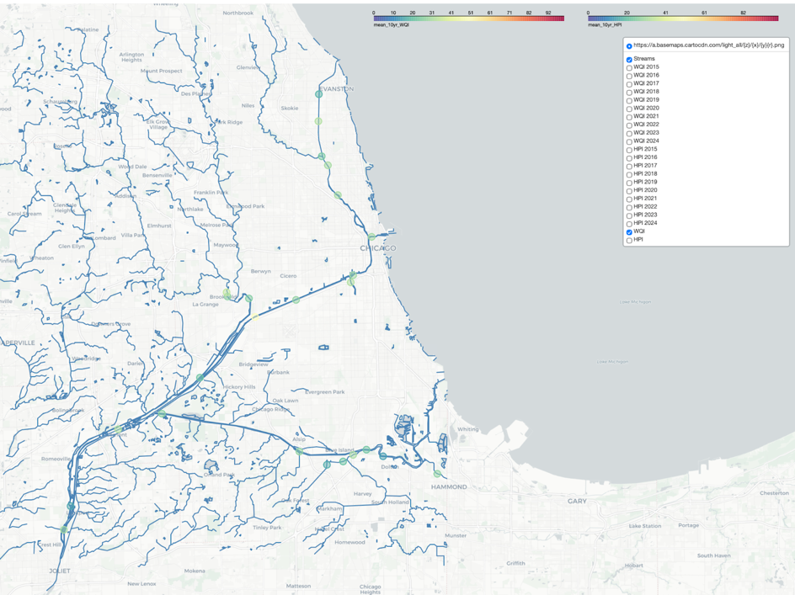cleaning, we assumed that values reported as less than their minimum reporting/detection limit to be at their minimum and defaulted to dropping the ‘<’ for those observations. Without better data for these years, or specific information about the changes protocol, we have chosen to ignore 2015-2018 HPI values in our downstream analyses.

Figure 3: 10 year average of WQI across selected sampling sites in the CAWS

After omitting 2015-2018 data, it was notable that only one of the sites exhibited a consistent HPI of greater than 100. On our HPI scale, a value of exactly 100 indicates that a given parameter is exactly equal to its permissible limit, as defined by the IPCB. Values of less than 100 indicate the observed parameter is less than the permissible value, while greater values indicate that it is above the threshold. The singular site (WW_86, on the Grand Calumet River) with a 10-year value greater than 100 indicates that, on the whole, Chicago’s waterways are not very polluted with heavy metals.

Across years and space, WQI showed to be somewhat homogenous, with slight seasonal variation. Our WQI is primarily a function of nutrients, organic matter, and biologics - all factors that we would expect to rise during the summer months as a result of warmer temperatures, increased rainfall and runoff, and sunlight availability. Overall, our WQI means fell within the range of “good” or “excellent” water quality, indicating that Chicago waterways are, for the most part, supportive of aquatic life.

Though outlier data points were not included in our final analysis, it was notable that many of the WQI outliers we initially observed were a factor of extremely large (2-3 orders of magnitude higher than average) fecal coliform counts. Though we did not directly correlate these with extreme rainfall events, it is likely that these large increases were the result of combined sewage overflow events which occur when large amounts of precipitation overwhelm the existing sewer system and overflow into waterways. Chicago is currently in the final phases of construction for its Tunnel and reservoir plan, a large underground sewer overflow system designed to capture and transport excess sewage and runoff during extreme precipitation. The project is slated for completion in 2029. Future research should investigate whether this infrastructure indeed reduces the occurrence of such outlier spikes in Fecal Coliform.

HPI showed a modest decline over years analyzed, possibly indicating reduced pollution or runoff due to infrastructure developments like TARP, though we did not run statistical tests on these trends to determine whether they were significant. HPI had small seasonal changes, but further research and analysis is required to understand if these are random or influenced by factors like runoff or temperature.  The HPI results were alarming for WW_86, a point on the Grand Calumet River near a large industrial site.

Because HPI is a weighted index of measured metal values evaluated against hardness-dependent regulatory standards, it is best interpreted as a relative indicator of heavy metal “stress” rather than as a statement of compliance or non-compliance for surface waters. It also should be noted that heavy metals often bind to suspended particles and eventually accumulate in the sediments. As all of our data comes from surface water samples, our analysis likely does not reflect the total amount of metals present in the waterway, just the water column itself.

*Spearman Correlations*

The spearman correlations among water-quality variables revealed several clusters of co-varying parameters. Salt related ions (Cl, SO₄, Ca, Mg, hardness, TDS) showed strong positive associations, likely indicating a common salting or de-icing source. Suspended solids (SS, VSS), nutrients (TKN, NH₃, Tot P), and TOC were also positively correlated, consistent with runoff of particulate and organic materials. Trace metals (Fe, Mn, Ni, Zn, Cu, Ba, B) tended to increase with solids and TOC, suggesting primarily associated transport. WQI was positively related to nutrients and solids, and negatively related to DO, reflecting responses to organic loading, whereas HPI correlated most strongly with the dissolved metal suite, confirming that it captures a distinct trend rather than serving as an alternative to WQI. To further visualize and investigate these relationships, we decided to perform a PCA further along in our analysis.

Figure 4: Spearman correlation heatmap showing significant (p>0.05) correlations between parameter level changes between samplings. Several clusters are apparent and investigated further later by PCA analysis.

*Accumulation and Depletion Boxplots*

Nearly all variables exhibited a higher median ending reading than starting reading, indicating they accumulate across the channels.  The appendix includes the full set of boxplots across all variables analyzed.  The table below summarizes trends of accumulation or depletion across all variables:

Figure 5: Summary of accumulation/depletion boxplot analysis. Boxplots in appendix.

The exceptions were:

* HPI, which showed a noticeable decrease along the Little Calumet River, inflated by relatively high heavy metal readings pouring in from the Grand Calumet River
* pH, which was fairly level except for a decline in the Little Calumet River
* Mercury, which has low solubility and may easily be lost to the atmosphere in the form of mercury vapor instead of building up down the waterway
* Dissolved oxygen, which may be due to further buildup of nutrients and eutrophication along the channel
* Cu sol, largely a fall in the North Branch Canal, which starts in the loop where there may be large amounts of urban runoff from break wear and building/plumbing materials.  Most other sites are at or below threshold levels.  It increases in the North Shore Channel, which starts in close proximity to the lake and has limited initial pollution.
* Chlorophyll-A: inconsistent throughout the channels.  Because the Chicago riversheds are eutrophic, additional nutrient buildup doesn’t seem to have a large effect on chlorophyll levels.  It is driven by other factors to be discussed in PCA.

Nearly all variables and waterways exhibit increases from start to end of the waterway.  The exceptions are organic water chemistry readings, which are influenced by the buildup in other variables

*Time Series and Seasonality of WQI, Cl, and HPI*

The time series and seasonality of WQI, Cl, and HPI revealed several significant trends:

* WQI: levels are sporadic, with large pollution events due to extreme outliers in certain variables.  There is no long-term trend, but there is some seasonality (higher values in the summer), which we try to explain using average rainfall values in Chicago (see figure descriptions below).
* Cl: Cl is the primary non-sodium component of road salts.  As expected, levels increase dramatically in winter months.  More concerningly, there is a small increase in Cl levels over all years analyzed, which may indicate a gradual accumulation as salts are deposited in sediment and absorbed by the water.
* ***A screenshot of a graph

  AI-generated content may be incorrect.***HPI: heavy metals index values decrease across.  There’s a small decline in HPI from 2018 to 2024 when applying a linear trend.  This may be due to the implementation of TARP, which is preventing extreme runoff events during flash flooding.  All channels have generally higher end than start values except for the Little Calumet River, which is fed by the extremely polluted Grand Calumet River.

Figure 6: The four scatterplots above describe Cl readings from January 2015 to December 2024 for each of the watersheds analyzed. Cl was used as a proxy for road salting because it is the primary non-sodium ingredient. There is a clear trend in seasonality with huge spikes in Cl during the winter.  We found a small, gradual buildup in Chlorine levels across several of the watersheds, possibly due to accumulation of Cl in sediment after subsequent salting. Extreme outlier events decreased considerably in 2023. Coincidentally, Chicago instituted salt monitoring in 2021 and urged the public to reduce road salting.

Cl levels exhibited seasonality, rising in winters.  A general increase in base salt levels was observed across the years analyzed using a simple regression test, indicating a potential buildup in salt levels over time in the form of ground deposits or ions dissolved in the lake.

*PCA – Full CAWS*

The full-system PCA explained 41.7% of the total variance (PC1 = 21%, PC2 = 12.4%, PC3 = 8.3%). As shown in fig. X, PC1 exhibited strong negative loadings for VSS, Tot P, F, Fe, SO₄, Ni, CN, and B, and strong positive loadings for TDS, Ca, Mg, Hardness, and Cl. This axis appears to separate waters dominated by suspended solids, nutrients, and redox-sensitive metals (negative side) from waters enriched in dissolved ions and carbonate hardness (positive side). In practical terms, PC1 seems to represent a gradient between organic/nutrient runoff and salting/mineral-rich runoff.

PC2 was shaped primarily by positive contributions from Fe, VSS, SS, SO₄, Hardness, and Mg, forming a redox-solids enrichment axis that can differentiate more industrially influenced waters from cleaner ones. PC3 captured a balance between positive contributions from CN, Cu, Chlorophyll-a, and SS and negative contributions from TKN, NH₃, Tot P, and several trace metals. This suggests a gradient between organically enriched waters and nutrient-dominated waters.

The overall score structure (fig. X) formed two distinct radiations. One radiation was composed almost entirely of higher-WQI samples, which also showed the strongest directional changes along the PCA axes. For this high-WQI group, as PC1 decreased, PC2 increased and WQI worsened, indicating a deterioration in water quality consistent with elevated solids, nutrients, and metals. Conversely, as PC1 decreased and PC3 increased, WQI improved slightly, implying that the organic-rich/trace-metal gradient represented by PC3 may moderate the worst water-quality conditions.

The second cluster formed a dense, rounded grouping with no clear WQI trend, representing a more stable “core” water-quality regime. Taken together, the full-system PCA suggests that CAWS water quality is organized into a relatively consistent baseline regime and a more variable, degraded-quality regime that responds strongly to changes in solids, nutrients, and redox-active metals.

PCA analysis for separate waterways can be found in the appendix.

Figure 7: Loadings of variables on principal components (PC)1-3 for the full CAWS.

Figure 8: Score cloud of PC1-3 colored by normalized WQI. Here we see two main regimes, a stable core and a radiation of degraded WQI.

|  |  |  |  |  |  |  |
| --- | --- | --- | --- | --- | --- | --- |
| Branch**​** | Variance Explained**​** | PC1**​** | PC2**​** | PC3 **​** | Key Characteristics and WQI Relationship**​** | Land Use & Functional Context**​** |
| **Full CAWS**​ | 41.7%​ (21.0 + 12.4 + 8.3)​ | Hardness/Ions vs. Solids/Nutrients (TDS, Ca, Mg vs. VSS, Tot P, Fe)​ | Redox-Solids Enrichment (Fe, VSS, SS, SO₄)​ | Organic vs. Nutrient Enrichment (CN, Cu, Chl-a vs. TKN, NH₃)​ | Two clear regimes: a stable core and a degradable radiating arm. WQI worsens with solids/nutrient enrichment (↓PC1, ↑PC2).​ | Aggregate System: Integrates all upstream sources, wastewater effluent, and industrial inputs from across the urban and suburban watershed.​ |
| **North Branch Canal**​ | 49.3%​ (23.0 + 15.4 + 10.9)​ | Solids/Nutrients vs. Hardness/Ions (Tot P, SS, Fe vs. TDS, Ca, Mg)​ | General Enrichment Axis (solids, nutrients, metals)​ | Trace Metal (As, Ba, Ni)​ | Uniform, diffuse score cloud. No strong WQI separation. Suggests consistent mixing.​ | Upper Canal & Residential: Lower industrial density, receives urban runoff and some treated wastewater. Acts as a mixing conduit before joining the main system.​ |
| **North Shore Channel**​ | 45.6%​ (21.5 + 14.2 + 9.9)​ | Solids/Nutrients vs. Hardness/Ions (Tot P, VSS, Fe vs. TDS, Cl, Hardness)​ | Metals & Solids Variability​ | Mixed Organic-Nutrient​ | Large cluster with WQI increasing as PC3 increases. PC3 acts as a secondary water-quality axis.​ | Diversion & Residential: Primarily conveys diverted Lake Michigan water and stormwater through residential and parkland areas. Lower direct industrial input.​ |
| **Chicago S&S Canal**​ | 44.4%​ (23.0 + 13.1 + 8.3)​ | Hardness/Ions vs. Solids/Nutrients​ | Redox-Solid Enrichment (resembles full system)​ | Organic–Nutrient Contrast​ | Most resembles full CAWS. Has a dominant high-WQI group with two radiating arms. WQI increases with PC3.​ | Main Collector & Industrial Corridor: The primary artery for combined wastewater effluent, CSO inputs, and legacy industrial discharges. Central "pollution highway" of the reversed system.​ |
| **Little Calumet River**​ | 44.5%​ (22.9 + 14.6 + 7.0)​ | Solids/Nutrients vs. Hardness/Ions (with strong trace metal influence)​ | Joint Solids-Nutrient-Metal Rise​ | Nutrient vs. Metal Chemistry​ | Compact cloud. WQI increases as PC3 decreases. Shows joint rise of solids & nutrients (↑PC1, ↑PC2).​ | Heavy Industry & Legacy Pollution: Drains a historic heavy industrial (steel, manufacturing) corridor. Characterized by chronic legacy pollutant loading (metals, solids).​ |

Across the CAWS, PCA revealed consistent underlying gradients, but each branch expressed these gradients differently depending on its position, hydrology, and land-use exposure. The loadings indicated that the dominant water-quality axis (PC1 across nearly all branches) opposed mineral-ionic, hardness-driven conditions to high-solids, nutrient-rich, redox-active conditions. This aligns with known processes in Chicago’s engineered waterways: salting and groundwater-mineral inputs tend to increase TDS, Ca, Mg, and Cl, while urban runoff, effluent discharges, storm events, and resuspension of benthic material elevate solids, nutrients, chlorophyll, and redox-sensitive metals.

PC2 and PC3 provided finer distinctions. PC2 generally captured a solids-and-redox-metal enrichment gradient, consistent with the industrial corridors and legacy sediment mobilization that characterize the Ship Canal and Little Calumet. PC3 typically partitioned organic enrichment from nutrient enrichment, which helps explain why WQI trends differed across branches depending on which of these processes dominated local conditions.

These gradients interact with the city’s hydrologic history and "dilution is the solution to pollution” slogan. Chicago’s reversal of its river fundamentally altered how contaminants disperse. Instead of flowing to Lake Michigan, urban runoff, treated effluent, and industrial discharges now move west and south toward the Des Plaines and Mississippi basins. The results of this PCA effectively trace how this engineered system channels different water-quality regimes along its branches. For example, North Branch Canal and North Shore Channel display a relatively uniform score cloud with no major water-quality bifurcation, consistent with their roles as smaller upstream conduits where dilution and mixing are more immediate.

The Chicago Ship Canal, the primary collector of citywide effluent and industrial inputs, most strongly reflects the full-system PCA. Its distinct radiating arms–one consistently high-WQI and one lower-WQI–highlight the variable contributions from the wastewater treatment system and industrial sources. The Little Calumet River, draining a heavily industrial southern corridor, expresses strong metals-nutrient-solids interactions but with a more compact overall structure, consistent with chronic rather than episodic pollutant loading. The absence or presence of WQI gradients in each branch mirrors their functional roles. Branches closer to Lake Michigan or characterized by more constant flows show stable WQI signatures. In contrast, the Ship Canal and portions of the Little Calumet show strong degradative gradients consistent with accumulation and mobilization of industrial contaminants–directly aligning with ongoing debates about downstream eutrophication and pollutant transport into the Des Plaines and Mississippi systems.

Overall, the combined PCA results support a picture of the CAWS as a hydrologically engineered system with distinct chemical personalities rooted in local land use, pollutant inputs, and the legacy of river reversal. The system contains both stable, well-mixed water-quality regimes and more volatile corridors where nutrients, solids, and redox-active metals drive dynamic shifts in water quality.

**Conclusion**

Our detailed review of Chicago’s MWRD data revealed that variables cannot be analyzed independently – many variables move together and influence each other in unexpected ways.  Utilizing indexes like WQI and HPI – which pull together different samples and test their departure from mean or acceptable values – provide a more comprehensive assessment of pollution vectors.  The results of these indexes are further influenced by the changing of seasons, the flow of waterways, geographic proximity to urban centers and industrial sites, accumulation over years (like rising salt levels and potentially falling heavy metals), and many other factors not considered here.  To fully understand Chicago waterway health and pollution, a multi-faceted approach needs to address heavy metal sources, salt runoff, and organic nutrient overloads with a tailored pollution index that answers specific questions around nutrient overloads, heavy metals, salt runoffs, and relationships between each.

**Limitations**

The breadth of information limited the time and resources available to analyze each metric.  While the use of indexes and PCA analysis uncovered some of the driving forces between variables, there are still nuanced relationships that could be analyzed through further research.

Because road salting is only applied during the winter, it’s hard to delineate its impact on water chemistry and organics from other changes like temperature and snowfall.

Testing sites were limited on some of the smaller waterways, and the true effects of accumulation and depletion would be better understood through inclusion of all sampling locations and additional GIS data – like proximity to industrial sites, lakes, tributaries, nature, and impermeable surface cover, amongst other geographic features.

**Future Directions**

Each one of these variables could be analyzed in detail, running through the full set of analysis: timeseries, seasonality, PCA, and geographic considerations.  By understanding each variable in detail, a new water quality index could be created that factors in the changes required.

Future analyses and data sources to consider:

* Pairing with other data sources such as precipitation, CSOs
* Maybe making an interactive dashboard to let people peruse through on their own
* How do these variables look in Lake Michigan, especially buildup of salt products like chlorine?
* How do extreme weather events like flooding affect variables?  Will these only become more frequent?
* What new infrastructure and policies in Chicago will combat some of these trends?

**Appendix**

|  |  |
| --- | --- |
| **CAWS Standards from Illinois Pollution Control Board Title 35** | |
| **WQI Constituent** | **Acute Standard** |
| pH | 6.5-9 |
| Dissolved Oxygen | 5 mg/L |
| Chlorine | 500 mg/L |
| Fecal Coliform | 200 cts/ml |
| Total Dissolved Solids | 1500 mg/L |
| Ammonia | 0.4111+107.204-pH+58.41+10pH-7.204 |
| Fluoride | *eA+Bln(Hardness)* (mg/L)  where *A* = 6.7319  and *B* = 0.5394 |
| Sulfate (where H is ≥ 100 but ≤ 500 and C is ≥ 25 but ≤500  H = Hardness, C = [Cl-] | (1276.7+5.508H - 1.457C) x 0.65 (mg/L) |
| Sulfate (where H is ≥ 100 but ≤ 500 and C is ≥ 5 but ≤ 25) | (-57.478 + 5.79H +54.163C) x 0.65 (mg/L) |
| Sulfate (where H > 500 and C ≥ 5) | 2000 mg/L |
| **HPI Constituent** | **Acute Standard** |
| Arsenic (dissolved) | 340 µg/L |
| Chromium | *e*A+Bln(H) x 0.316  Where A = 3.7256 and B = 0.8190 |
| Copper | *e*A+Bln(H) x 0.960  Where A = -1.6745 and B = 0.9422 |
| Cyanide | 22 µg/L |
| Boron | 40,100 µg/L |
| Barium | 5 mg/L |
| Iron | 1 mg/L |
| Manganese | *e*A+Bln(H) x 0.9812 µg/L  Where A = 4.9187 and B = 0.7467 |
| Mercury | 1.2 µg/L |
| Nickle | *e*A+Bln(H) x 0.998 µg/L  Where A = 0.5173 and B = 0.8460 |
| Zinc | *e*A+Bln(H) x 0.978 µg/L  Where A = 0.9035 and B = 0.8473 |

|  |
| --- |
| **Formulas for Calculation of WAWQI** |
| Eqn 1:  Qn= 100Vn -VOSn-VO |
| Eqn 2:  Wn=KSn |
| Eqn 3: K = 1  1N1Sn |
| Eqn 4: WQI = QnWnWn |
| WQI Equations: Standard permissible values (Sn) were calculated according to the Illinois Pollution Control Board’s standards for Chicago Waterways. (Vn=observed, Sn=Permissible, VO=ideal, K=constant of proportionality, Wn=parameter weight, Qn= sub-index)   |  |  | | --- | --- | | **Formulas for Calculation of HPI** | | | **Eqn 5:  Qn= 100Vn -VOSn-VO** | **HPI Index Level Interpretation** | | **Eqn 6:  Wn=KSn** | < 100 = Within Permissible Threshold | | **Eqn 7:***K = 1* | 100 = At Threshold, Maximum ‘Safe’ Heavy Metals | | **Eqn 8: HPI = QnWnWn** | >100 = Above Threshold, Elevated Heavy Metals | | HPI Equations: Standard permissible values (Sn) were calculated according to the Illinois Pollution Control Board’s standards for Chicago Waterways. (Vn=observed, Sn=Permissible, VO=ideal, K=constant of proportionality, Wn=parameter weight, Qn= sub-index); For a given parameter (or set of parameters in an observation), an HPI of exactly 100 means that the parameter (or all parameters) is exactly equal to its permissible level. | | |

Figure 9: Boxplots comparing start and end salt index levels. Salts (primarily from road salting) built up throughout all water channels.

Figure 10: The four scatterplots above describe WQI readings from January 2015 to December 2024 for each of the watersheds analyzed. Extreme outliers were excluded from the range in order to see smaller fluctuations. We found no long-term trends in WQI; however, there does appear to be a generally higher level in the summer.

Figure 11: Average WQI levels for each month across all years of data and channels at starting station (red) and ending station (blue). As discussed above, there is an elevated WQI for the duration of the summer. This may be due to higher rainfall over the spring  and summer leading to more runoff and flooding. The warmer weather may also cause blooms in the eutrophic rivers, creating anoxic conditions.

Figure 12: Average rainfall in Chicago (using Ohare Airport 2006 - 2020 data as a proxy). The rises and dips in WQI appear to move with corresponding changes in rainfall.

Figure 13: Scatter of average Cl levels at starting stations (red) and ending stations (blue) for all years of data by month to assess seasonality. There is a clear increase in the winter, peaking at the start of February and dropping to a stable level (notably not zero) in June through September.  From there, it begins to increase slowly until a stark increase in December.

Figure 14: Average snowfall and temperature in Chicago (using Ohare Airport 2006 - 2020 data as a proxy). There's a notable rise in snowfall the same time that average temperatures fall below freezing alongside increasing snowfall (when it begins to accumulate on the ground).  There is also a notable decline in Cl when average temperatures rise above freezing from February to March.

Figure 15: Scatterplots of the HPI index by waterway January 2018 - December 2024. Red is starting site readings and blue is ending site readings. There appears to be a gradual decline in HPI over the timeframe when applying a linear trend.

North Branch Canal PCA

The North Branch Canal PCA explained 49.3% of the total variance (PC1 = 23%, PC2 = 15.4%, PC3 = 10.9%). PC1 showed positive loadings for Tot P, SS, VSS, F, SO₄, Fe, and B and negative loadings for TDS, Ca, Mg, and Hardness–an inversion of the full-system PC1 regime. Here, the positive side reflects nutrient- and solids-enriched water, while the negative side captures the high-ionic and hardness-dominated chemistry.

PC2 acted as a general enrichment axis across suspended solids, nutrients, and metals, while PC3 was characterized by strong positive contributions from trace metals such as As, Ba, and Ni.

The score space (fig. X) formed one large, diffuse cloud with no clear separation by WQI. The canal’s water quality appears relatively uniform, lacking the strong two-regime pattern seen in the full system. The primary trend in score space followed decreasing PC1 with increasing PC2, reflecting the antagonistic behavior between mineral-hardness chemistry and high-solids/high-nutrient loads. A small group of points extended along the PC3 dimension but did not align with PC1 or PC2 trends, suggesting short-duration local events rather than a persistent chemical structure.

North Shore Channel PCA

The North Shore Channel PCA explained 45.6% of total variance (PC1 = 21.5%, PC2 = 14.2%, PC3 = 9.9%). PC1 showed strong negative loadings for TDS, Cl, Ca, Mg, and Hardness and positive loadings for Tot P, VSS, SO₄, Fe, and F–closely matching the North Branch Canal PC1 pattern. This again reflects the tension between suspended-solid/nutrient enrichment and mineral-ionic content.

PC2 captured variability in metals and suspended solids, while PC3 contained a mixture of nutrients, organics, and trace metals with no single dominant group.

The score pattern (fig. X) formed a large, mostly flat cluster with WQI increasing as PC3 increased. Across PC1 and PC2, the data showed a diagonal trend where decreasing PC1 aligned with increasing PC2. The PC2 × PC3 projection formed a slightly conical pattern: one arm where PC2 decreased as PC3 increased rapidly (with WQI increasing), and another arm where PC2 decreased as PC3 increased more gradually (with consistently lower WQI). This suggests that PC3 acts as a secondary water-quality axis in this branch, particularly distinguishing chlorophyll- and organic-rich conditions from more mineral-rich conditions. On the PC1 × PC3 plane, the cluster remained a broad mass with WQI increasing mainly along PC3.

Chicago Sanitary and Ship Canal PCA

**

The Chicago Ship Canal PCA explained 44.4% of total variance (PC1 = 23%, PC2 = 13.1%, PC3 = 8.3%). This branch most closely resembled the full-system PCA, which is expected given its length and central position in the CAWS network. PC1 again represented the hardness-and-ionic content vs. solids-and-nutrients gradient, while PC2 reflected redox-solid enrichment and PC3 contained secondary organic–nutrient contrasts.

This branch’s score plot (fig. X) produced a dominant high-WQI grouping from which two radiating arms extended. One arm maintained high WQI and showed consistent increases in PC2 and PC3 as PC1 increased, while the other showed lower WQI and followed decreasing PC1 with increasing PC2. On the PC2 × PC3 plane, the high-WQI radiating arm was largely independent, whereas the lower-WQI arm maintained a stronger PC2 gradient. Across all projections, increasing PC3 corresponded to increasing WQI. This structure aligns with the canal’s role as the primary industrial and wastewater corridor, exhibiting the strongest variation in nutrient-metal-solid interactions.

Little Calumet River PCA

The Little Calumet River explained 44.5% of total variance (PC1 = 22.9%, PC2 = 14.6%, PC3 = 7.0%). PC1 and PC2 again reflected the solids-nutrient vs. hardness-ionic contrasts, but with greater influence from trace metals, consistent with this branch’s industrial landscape. PC3 had low explained variance but contributed additional differentiation through nutrient-rich vs. metal-rich chemistry.

The score space formed a large, compact cloud similar to the North Branch Canal. The clearest trend was that WQI increased as PC3 decreased. The dominant structure followed increasing PC1 aligning with increasing PC2, reflecting a joint pattern of solids, nutrients, and some metals rising together. A small radiating arm also appeared, where decreasing PC1 corresponded to increasing PC2–suggesting episodic solids or nutrient-rich inputs entering from industrial tributaries or stormwater events.

North Branch Canal

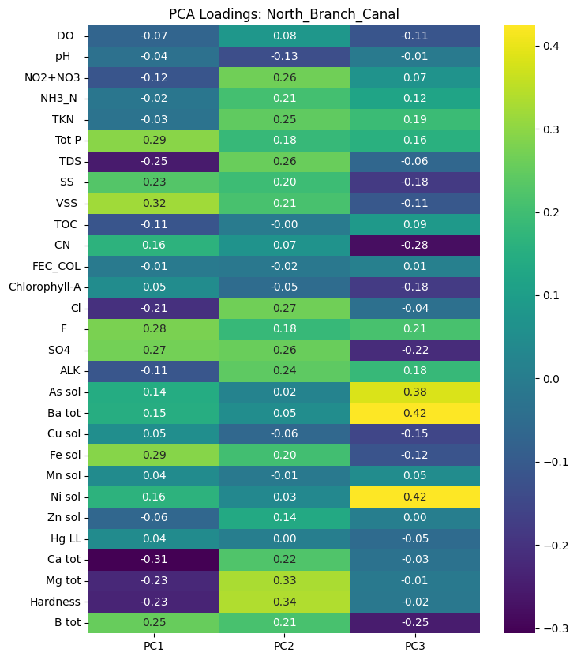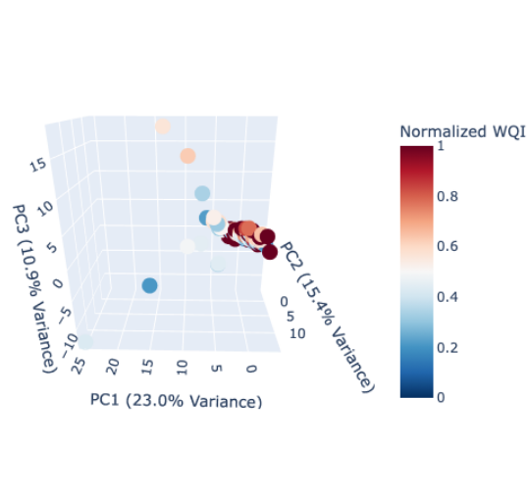

The North Branch Canal PCA explained 49.3% of the total variance (PC1 = 23%, PC2 = 15.4%, PC3 = 10.9%). PC1 showed positive loadings for Tot P, SS, VSS, F, SO₄, Fe, and B and negative loadings for TDS, Ca, Mg, and Hardness–an inversion of the full-system PC1 regime. Here, the positive side reflects nutrient- and solids-enriched water, while the negative side captures the high-ionic and hardness-dominated chemistry.

PC2 acted as a general enrichment axis across suspended solids, nutrients, and metals, while PC3 was characterized by strong positive contributions from trace metals such as As, Ba, and Ni.

The score space (fig. X) formed one large, diffuse cloud with no clear separation by WQI. The canal’s water quality appears relatively uniform, lacking the strong two-regime pattern seen in the full system. The primary trend in score space followed decreasing PC1 with increasing PC2, reflecting the antagonistic behavior between mineral-hardness chemistry and high-solids/high-nutrient loads. A small group of points extended along the PC3 dimension but did not align with PC1 or PC2 trends, suggesting short-duration local events rather than a persistent chemical structure.

North Shore Channel

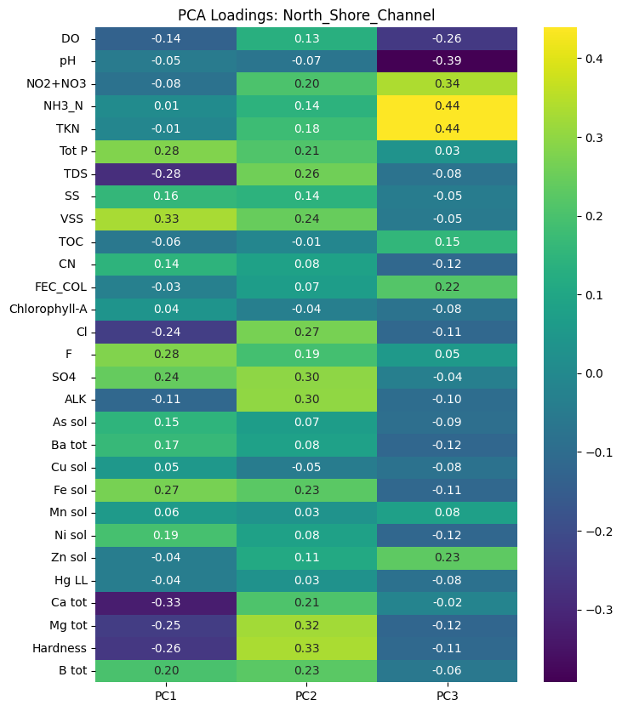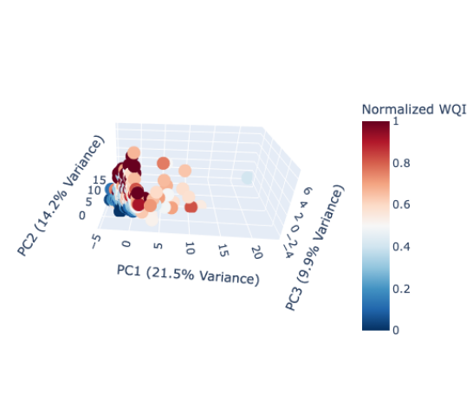

The North Shore Channel PCA explained 45.6% of total variance (PC1 = 21.5%, PC2 = 14.2%, PC3 = 9.9%). PC1 showed strong negative loadings for TDS, Cl, Ca, Mg, and Hardness and positive loadings for Tot P, VSS, SO₄, Fe, and F–closely matching the North Branch Canal PC1 pattern. This again reflects the tension between suspended-solid/nutrient enrichment and mineral-ionic content.

PC2 captured variability in metals and suspended solids, while PC3 contained a mixture of nutrients, organics, and trace metals with no single dominant group.

The score pattern (fig. X) formed a large, mostly flat cluster with WQI increasing as PC3 increased. Across PC1 and PC2, the data showed a diagonal trend where decreasing PC1 aligned with increasing PC2. The PC2 × PC3 projection formed a slightly conical pattern: one arm where PC2 decreased as PC3 increased rapidly (with WQI increasing), and another arm where PC2 decreased as PC3 increased more gradually (with consistently lower WQI). This suggests that PC3 acts as a secondary water-quality axis in this branch, particularly distinguishing chlorophyll- and organic-rich conditions from more mineral-rich conditions. On the PC1 × PC3 plane, the cluster remained a broad mass with WQI increasing mainly along PC3.

Chicago Sanitary and Ship Canal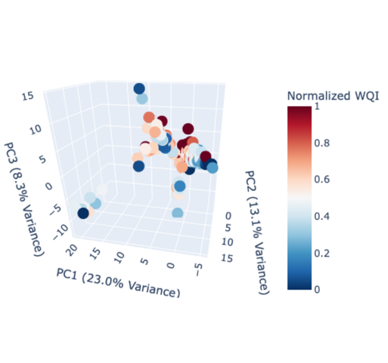

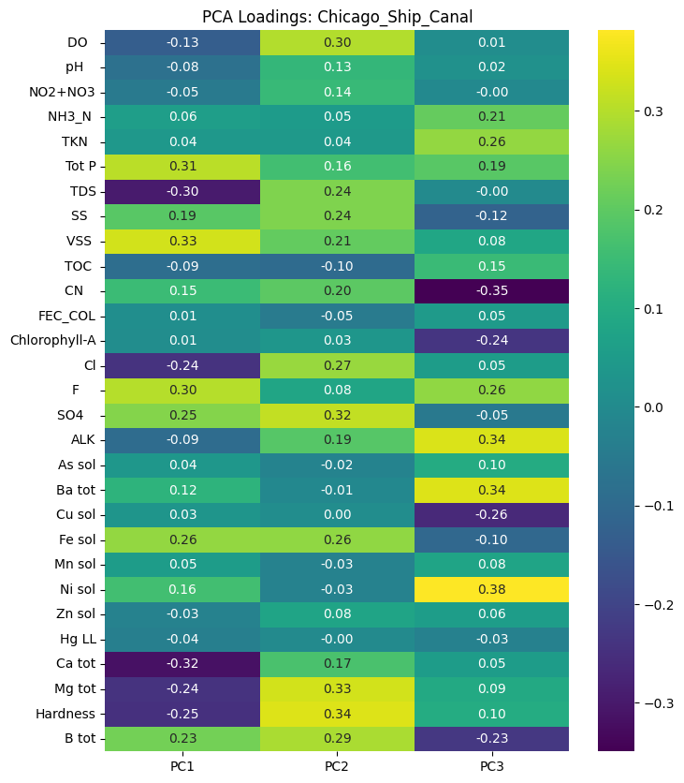

The Chicago Ship Canal PCA explained 44.4% of total variance (PC1 = 23%, PC2 = 13.1%, PC3 = 8.3%). This branch most closely resembled the full-system PCA, which is expected given its length and central position in the CAWS network. PC1 again represented the hardness-and-ionic content vs. solids-and-nutrients gradient, while PC2 reflected redox-solid enrichment and PC3 contained secondary organic–nutrient contrasts.

This branch’s score plot (fig. X) produced a dominant high-WQI grouping from which two radiating arms extended. One arm maintained high WQI and showed consistent increases in PC2 and PC3 as PC1 increased, while the other showed lower WQI and followed decreasing PC1 with increasing PC2. On the PC2 × PC3 plane, the high-WQI radiating arm was largely independent, whereas the lower-WQI arm maintained a stronger PC2 gradient. Across all projections, increasing PC3 corresponded to increasing WQI. This structure aligns with the canal’s role as the primary industrial and wastewater corridor, exhibiting the strongest variation in nutrient-metal-solid interactions.

Little Calumet River

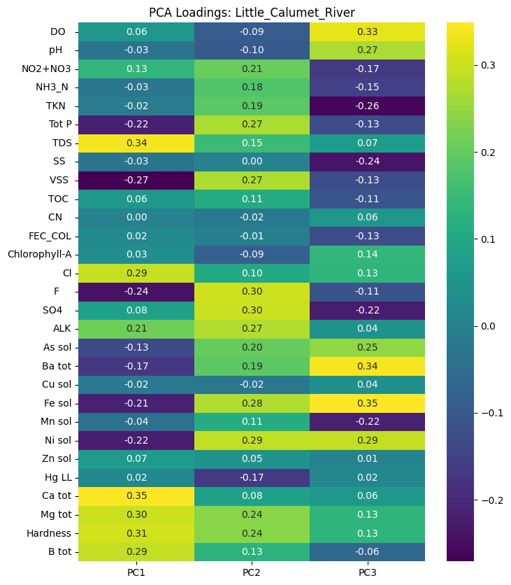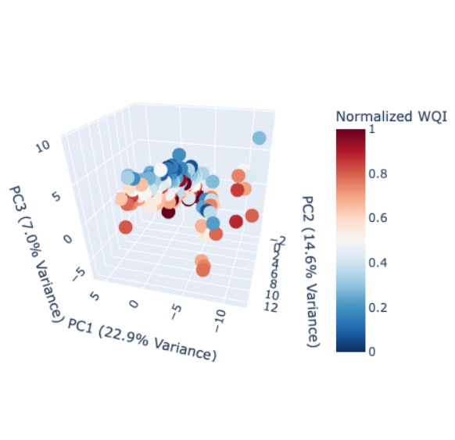

The Little Calumet River explained 44.5% of total variance (PC1 = 22.9%, PC2 = 14.6%, PC3 = 7.0%). PC1 and PC2 again reflected the solids-nutrient vs. hardness-ionic contrasts, but with greater influence from trace metals, consistent with this branch’s industrial landscape. PC3 had low explained variance but contributed additional differentiation through nutrient-rich vs. metal-rich chemistry.

The score space formed a large, compact cloud similar to the North Branch Canal. The clearest trend was that WQI increased as PC3 decreased. The dominant structure followed increasing PC1 aligning with increasing PC2, reflecting a joint pattern of solids, nutrients, and some metals rising together. A small radiating arm also appeared, where decreasing PC1 corresponded to increasing PC2–suggesting episodic solids or nutrient-rich inputs entering from industrial tributaries or stormwater events.

References

*Chicago and the Gulf Dead Zone: NRDC Lawsuits Address Downstream Damage*. (2012, March 13). https://www.nrdc.org/bio/ann-alexander/chicago-and-gulf-dead-zone-nrdc-lawsuits-address-downstream-damage

*Documents | MWRD*. (n.d.). Retrieved December 3, 2025, from https://mwrd.org/document-finder?name=waterway+ambient+water+quality&field_document_category_target_id=All&field_document_date_target_id=All

*NOAA NCEI U.S. Climate Normals Quick Access*. (n.d.). Retrieved December 3, 2025, from https://www.ncei.noaa.gov/access/us-climate-normals/?utm_source=chatgpt.com#dataset=normals-monthly&timeframe=15&location=IL&station=USW00094846

Overbo, A., Heger, S., & Gulliver, J. (2021). Evaluation of chloride contributions from major point and nonpoint sources in a northern U.S. state. *Science of The Total Environment*, *764*, 144179. https://doi.org/10.1016/j.scitotenv.2020.144179

WTTW (Director). (2017, November 28). *How Chicago Reversed Its River: An Animated History* [Video recording]. https://www.youtube.com/watch?v=kSsrrKMwPzQ